Homework Assignment 1
Predict the products of the following substitution reactions, and indicate which mechanism is preferred, SN2 or SN1.
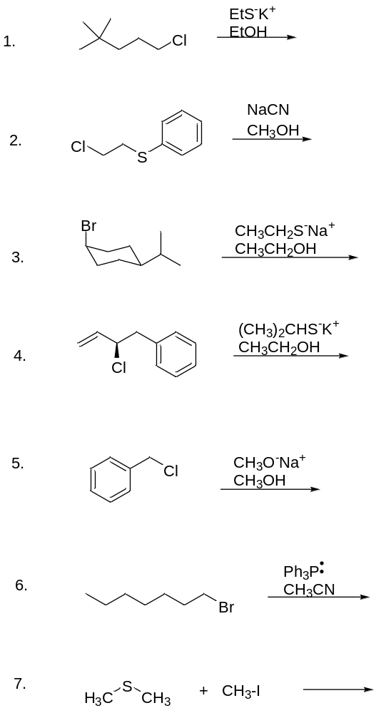

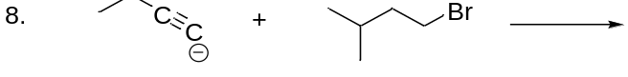

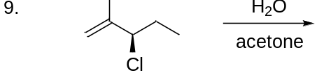
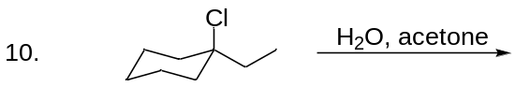

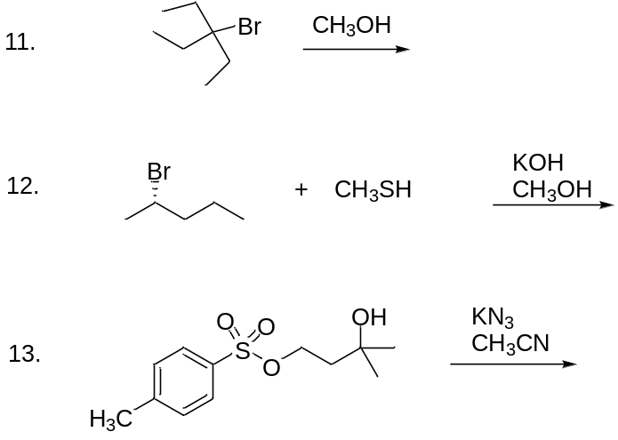

- SN2
- SN2
- SN1
- SN1
- SN1
- SN2
- SN2
- SN2
- SN1
- SN1
- SN1
- SN2
- SN2

